Data Structures and Algorithms

Printer Queue

You have to simulate the printer queue (printer’s printing jobs) by using Queue class. Queue follows FIFO (first in first out) rule. Recall that as students send printing tasks to the shared printer, the tasks are placed in a queue to be processed in a first-come first-served manner. You can understand it by the following picture.
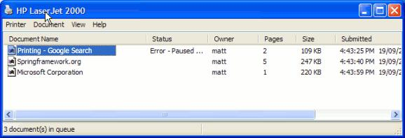

You have to work on PrintingJob where the printer is capable of storing and processing the input jobs. Each job has an associated timeOfArrival, and number of pages in the input file. The printer prints 6 pages in a minute. For example, consider if printing job is sent to a printer at 12:05:30 time and it is composed of 60 pages. It will take 10 minutes to complete this job, therefore it will start at 12:05:30, end at 12:15:30. During this one more job is arrived at 12:07:00 time, which is composed of 12 pages, then this job has to wait in the queue, and would be assigned the starting time as 12:05:30 and would take another 2 minutes to finish, thus would be marked with the end time 12:07:30.
Data Structures and Algorithms

You have to maintain queue and have to do the following:

- Calculate the total time for which all printing jobs will be done.

- Furnish each job with its start time and end time (i.e. when would the printer start printing a job, and when it would end printing it.)

Create a class PrinterQueue, create a function processJobs that takes input array of PrintingJobs where each job is represented with submissionTime, startTime, endTime, dataSize.

- At the time of submission each job is represented by numberOfPages and submissionTime.

- Whenever a new job is added to the queue, the system assigns it approximate startTime and endTime. It also shows the queue after every addition.

- The function processJobs manipulates all jobs using a queue one after the other and removes a job once it is complete. It also prints the queue after each deletion.

- It also computes the total time taken to print all jobs in the input array

